|  |  |
| --- | --- |
| **Title** | Workshop 3 Questions - Introduction to Data Models |
| **Author** | Prepared by Mr. Anmol Adhikari, Teams |
| **Date** | 3 July 2023 |

# Basic concept of E-R diagram

1. What is an E-R diagram and what is its purpose in database design?

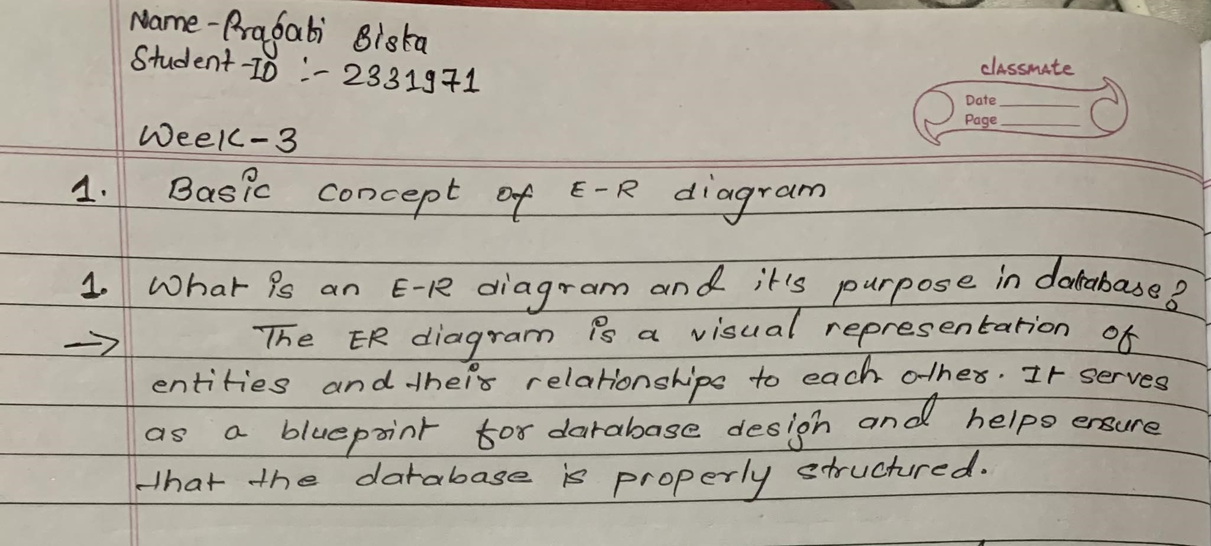

1. Explain the basic components or symbols used in an E-R diagram.

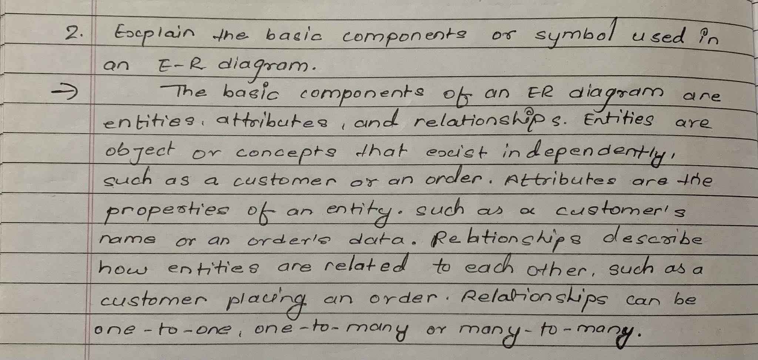

1. How does an E-R diagram represent entities, relationships, and attributes?

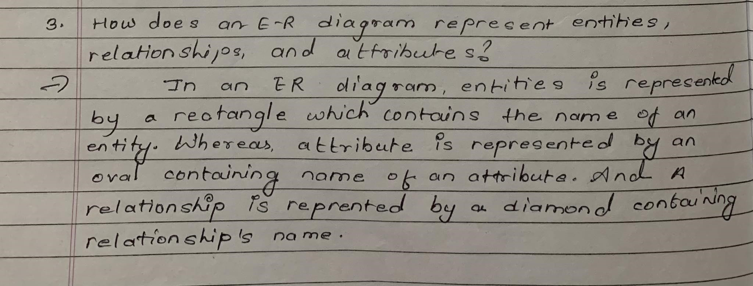

1. What are the benefits of using an E-R diagram in database modeling and design?
2. Give an example of an E-R diagram and explain its structure.

# Types of Attributes

1. Define the concept of attributes in an E-R diagram.

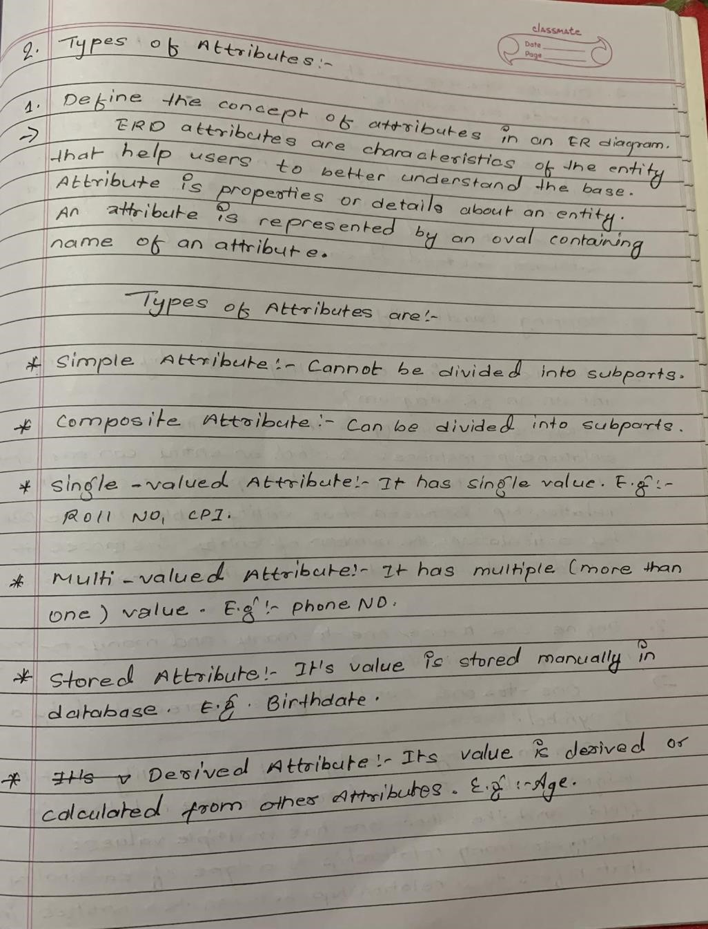

1. Explain the difference between simple and composite attributes.
2. What are the various types of attribute domains commonly used in E-R diagrams?
3. Discuss the concept of derived attributes and provide an example.

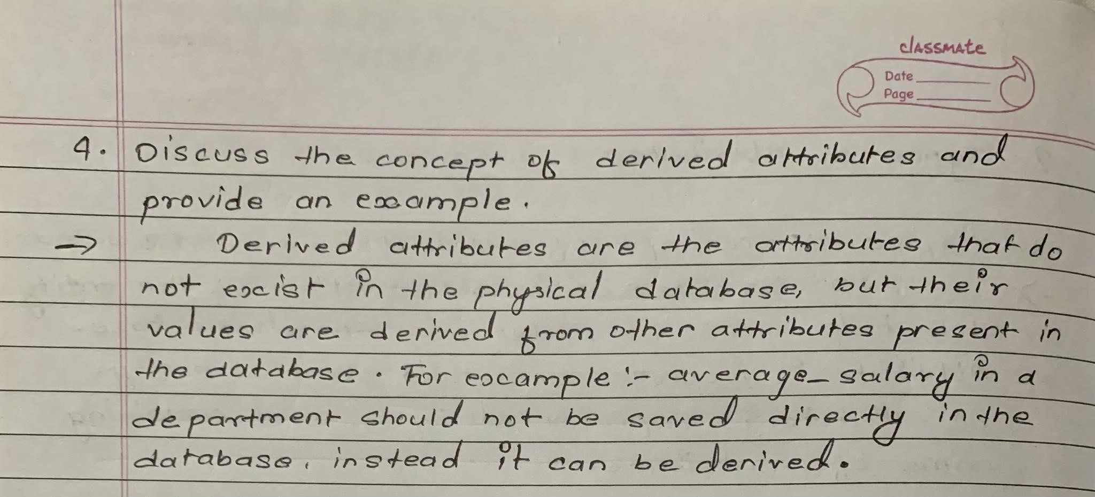

1. How are multivalued attributes represented in an E-R diagram?

# Mapping Cardinality

1. What is mapping cardinality and why is it important in an E-R diagram?

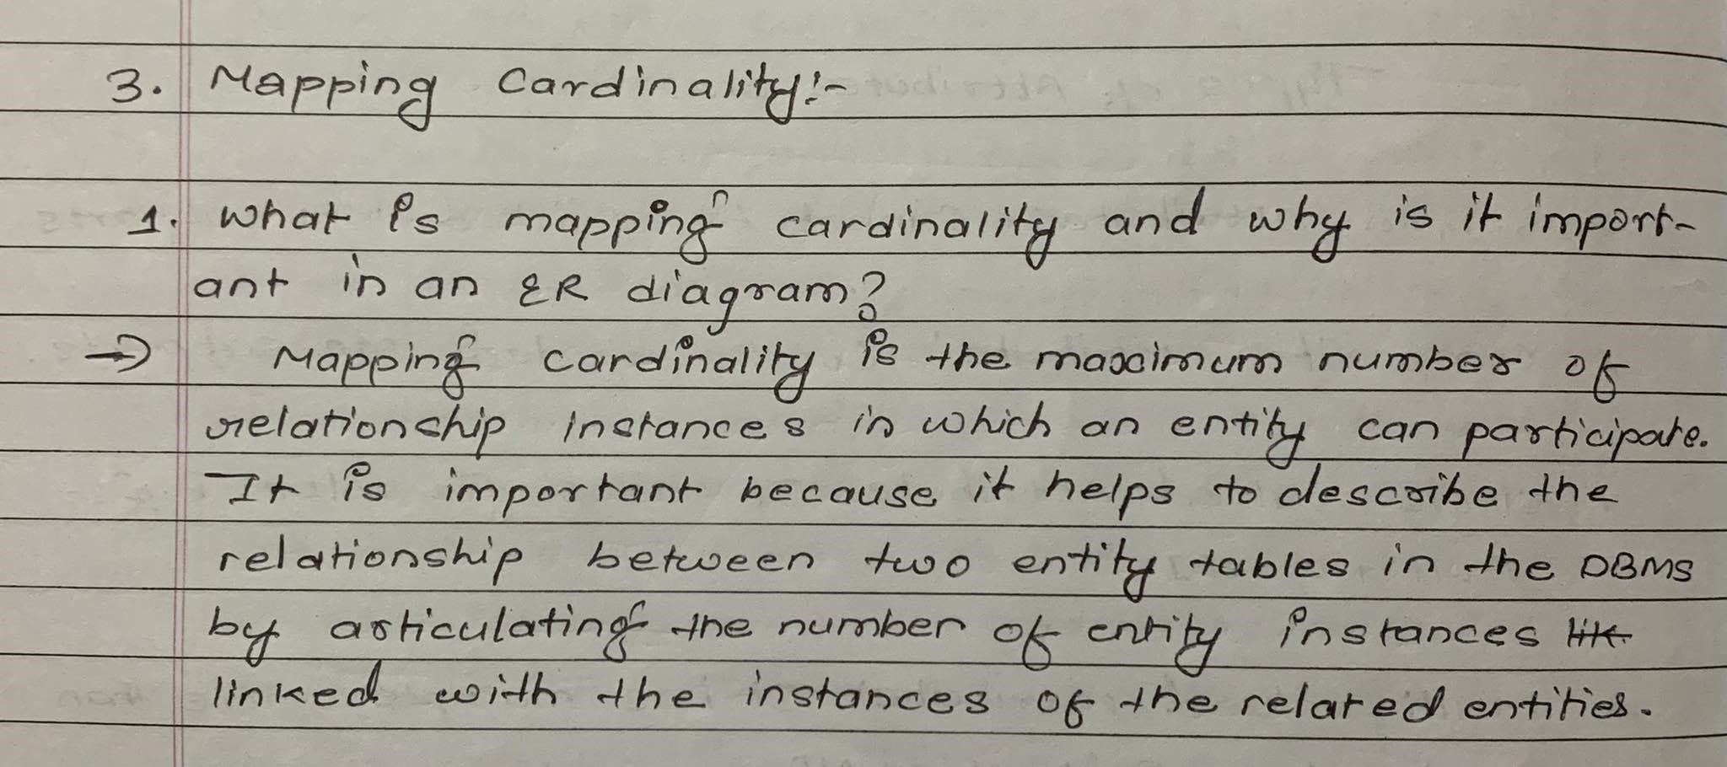

1. Define one-to-one, one-to-many, and many-to-many mapping cardinalities.

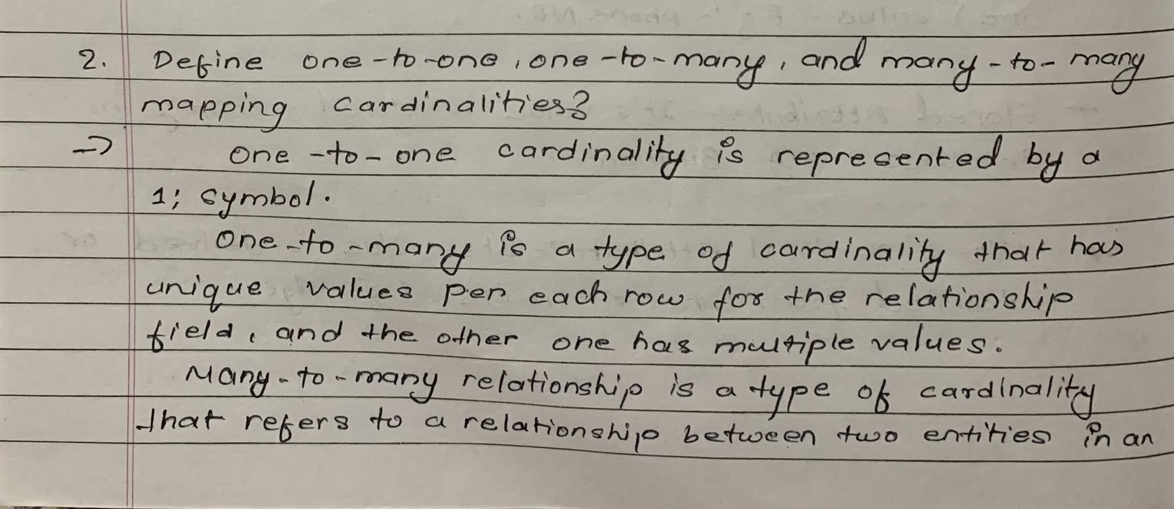

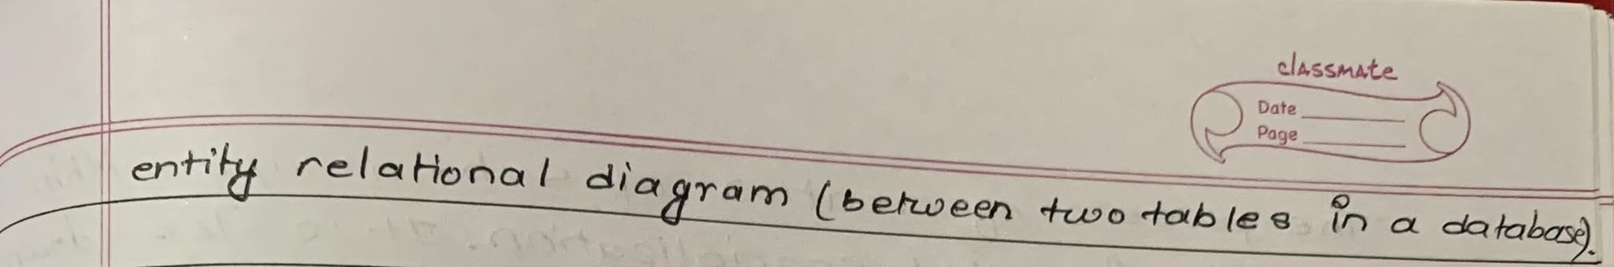

1. Provide an example scenario for each type of mapping cardinality.
2. How do you represent mapping cardinality in an E-R diagram?
3. Discuss the implications of different mapping cardinalities on database relationships.

# Weak Entity Sets

1. What is a weak entity set and how does it differ from a strong entity set?

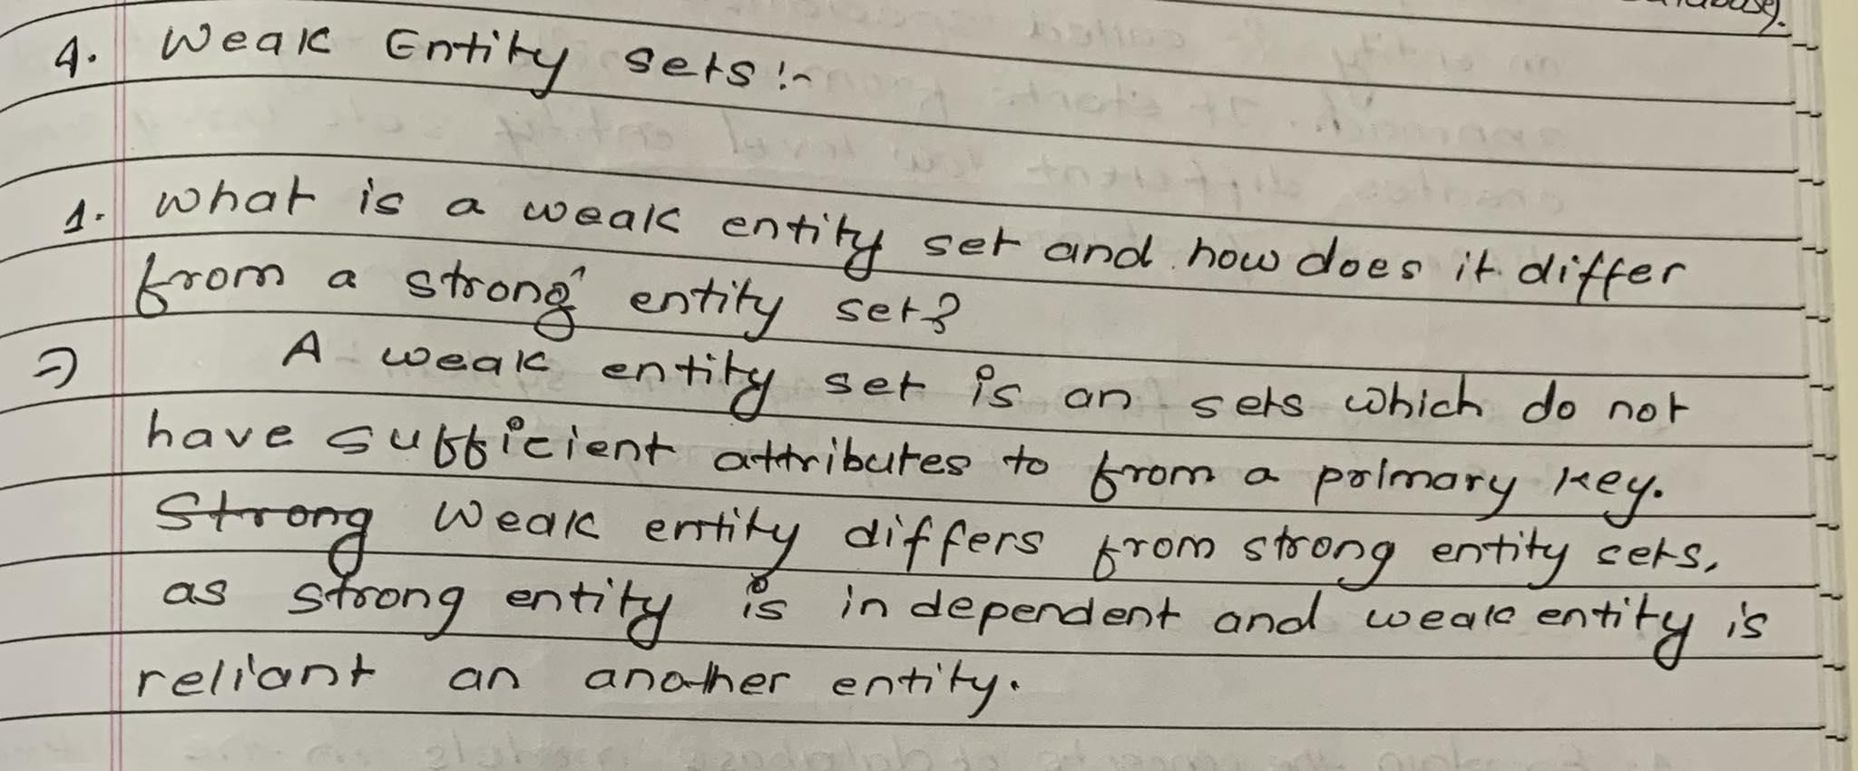

1. Explain the concept of a partial key in relation to weak entity sets.
2. How are weak entity sets represented in an E-R diagram?
3. Give an example scenario of a weak entity set and its identifying relationship.

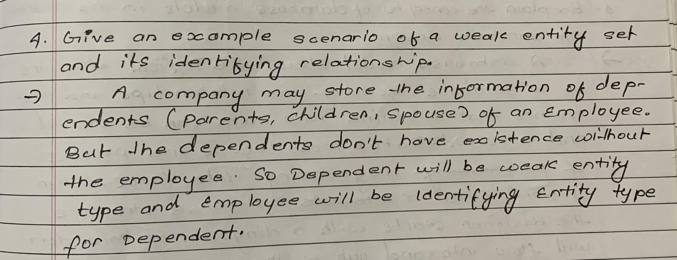

1. Discuss the purpose of weak entity sets in database design.

# Extended E-R features

1. What are the extended features or enhancements of an E-R diagram?
2. Explain the concept of aggregation in an E-R diagram.
3. Discuss the benefits and use cases of using aggregation in database modeling.
4. Define the concepts of generalization and specialization.

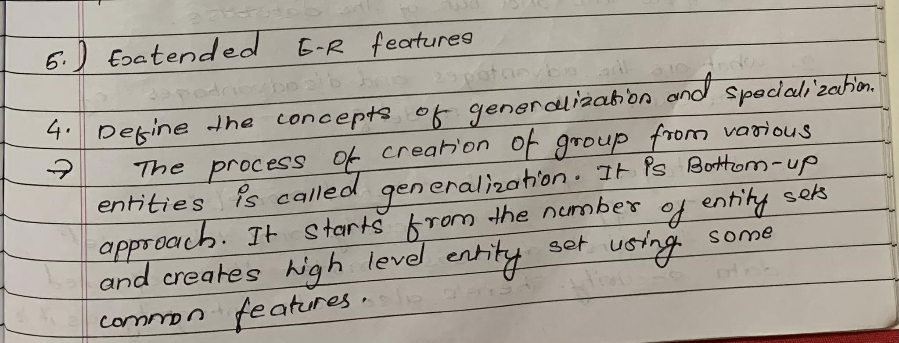

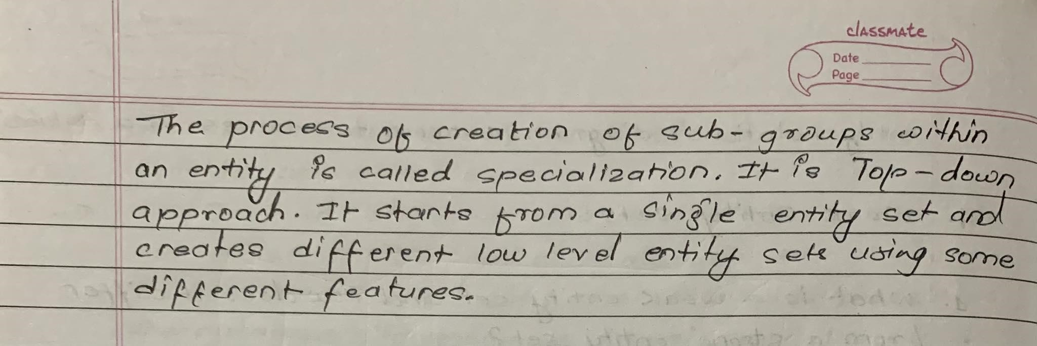

1. Provide an example scenario of generalization and specialization in an E-R diagram.

# E-R diagram for Bank Management System

1. Draw an E-R diagram for a Bank Management System that includes entities such as customers, accounts, transactions, and employees.

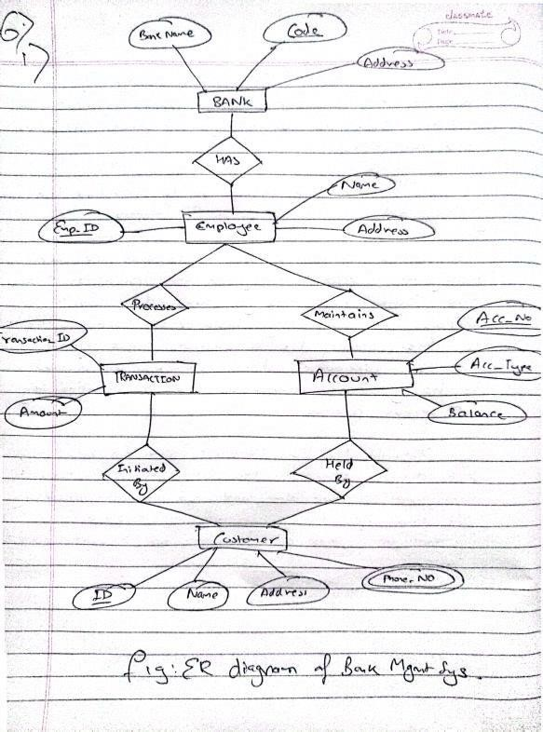

1. Identify the attributes associated with each entity in the Bank Management System.
2. Define the relationships between the entities in the Bank Management System.
3. Include cardinality constraints and any additional constraints or assumptions you deem necessary.
4. Explain the purpose and functionality of the Bank Management System based on the E-R diagram.

# E-R diagram for Library Management System

1. Draw an E-R diagram for a Library Management System that includes entities such as books, library members, library staff, and borrowing records.
2. Determine the attributes associated with each entity in the Library Management System.
3. Define the relationships between the entities, such as the borrowing relationship between library members and books.
4. Include cardinality constraints and any additional constraints or assumptions you deem necessary.
5. Discuss the functionalities of the Library Management System based on the E-R diagram and how it helps in managing library operations.

# E-R diagram for a Car-Insurance Company

1. Construct an E-R diagram for a car-insurance company that includes entities such as customers, cars, accidents, and insurance policies.
2. Identify the attributes associated with each entity, such as the car’s make, model, and registration number.
3. Determine the relationships between the entities, such as the ownership relationship between customers and cars.
4. Incorporate the relationship between accidents and cars, considering the possibility of multiple accidents per car.
5. Discuss the purpose of the E-R diagram for the car-insurance company and how it assists in managing customer policies and accident records.

# Database Models

1. Explain the concept of database models in the context of database design.

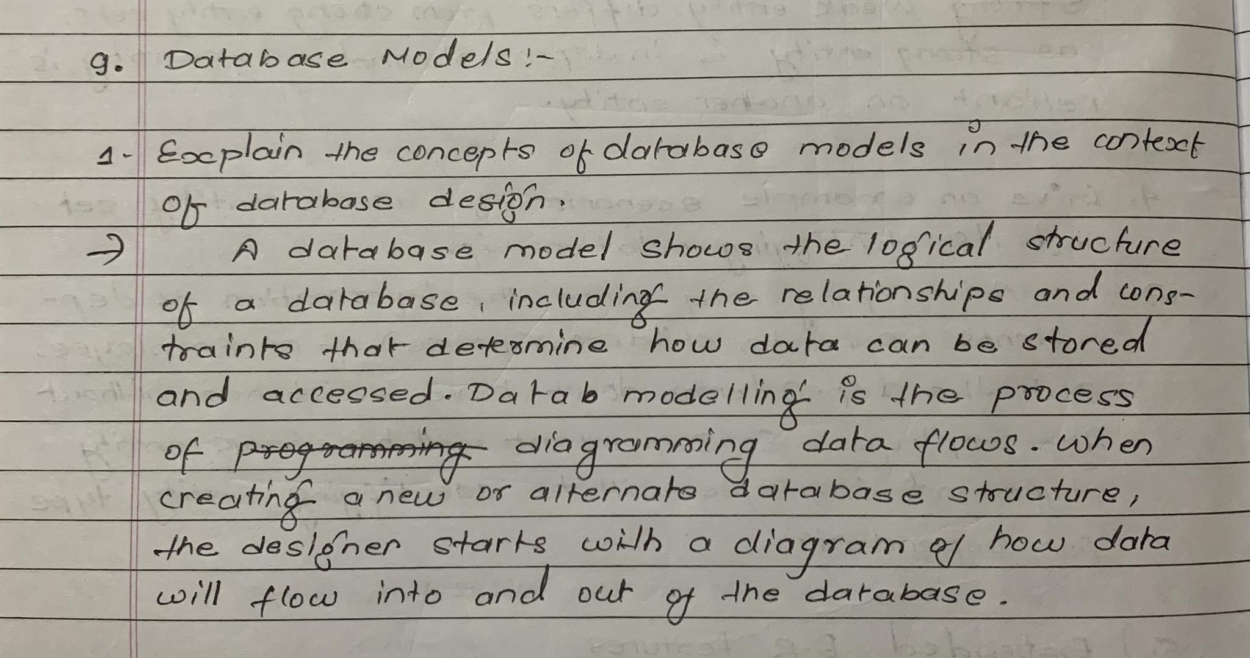

1. Discuss the advantages and disadvantages of hierarchical database model.

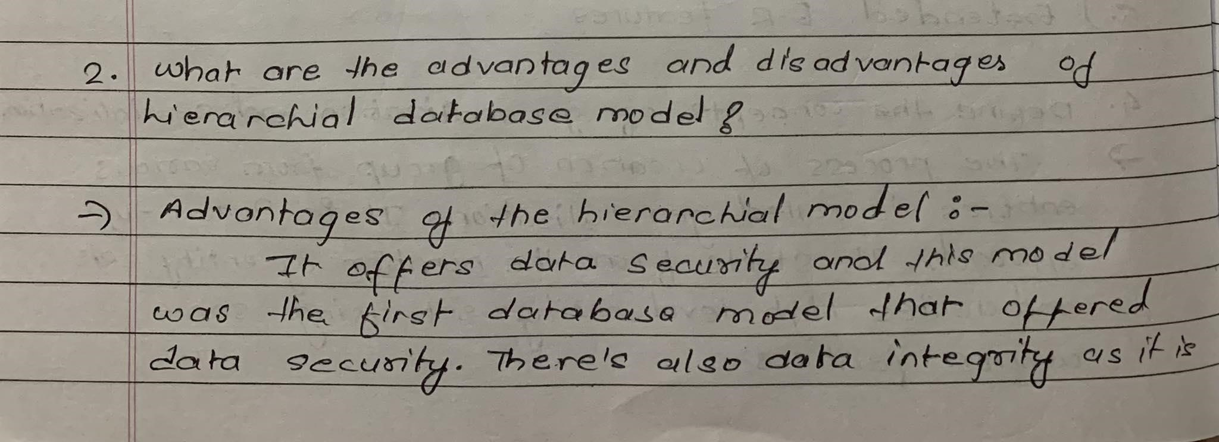

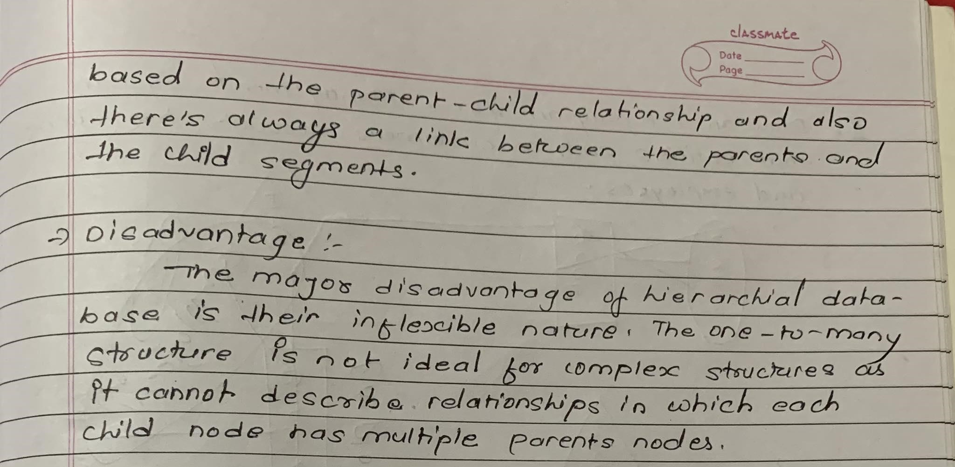

1. Define the relational database model and its key characteristics.
2. Compare and contrast the relational and hierarchical database models.
3. Provide an example scenario where a specific database model would be suitable.

# Note

**Important Note:** Please read and understand the following instructions carefully:

* All the questions need to be answered in your personal copy.
* You are allowed to take help from online sources to find relevant information and examples for the questions.
* The ER diagram should be hand-drawn in your copy using a pencil and other necessary items.
* These questions are designed to enhance your understanding of the importance of the ER diagram and its application in Level 5 & Level 6 Modules.

**Submission Guidelines:**

* While submitting your files to My Second Teacher, please follow the naming convention: **StudentID Name Groupname**.
* For example: **2030000 Ronit L4CG1**.

**Note:** Please ensure that you complete the questions and submit your work before the given deadline.

Good luck with your workshop and enjoy learning about data models!